Proposal Submission Instructions

- Navigate to website: www.srseedalliance.com

- Navigate to Research page of site:
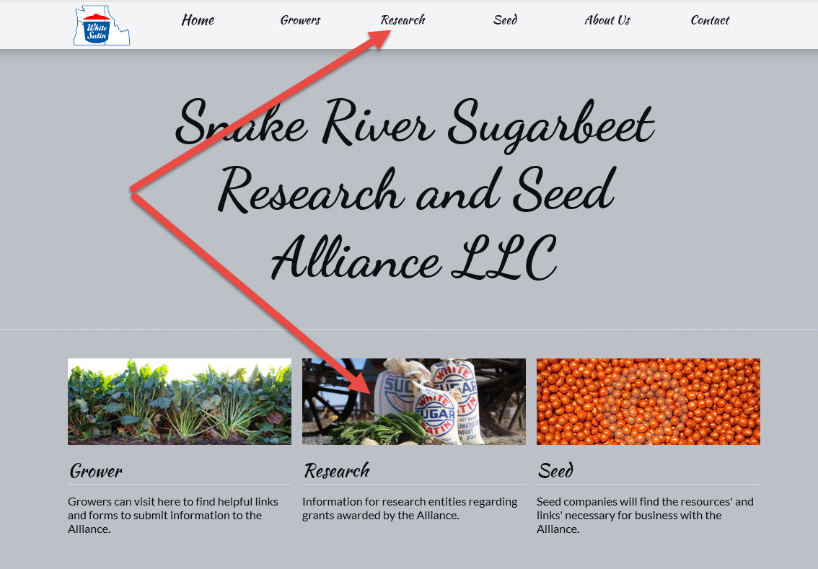

3. Locate Full Proposal Form download button and download the form:
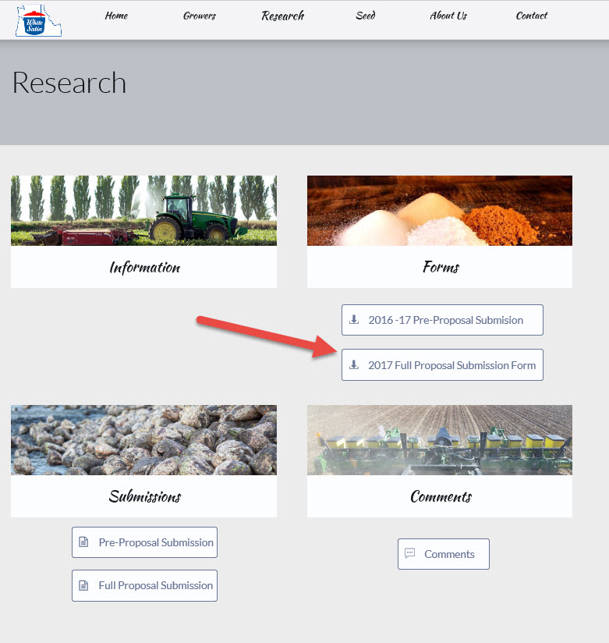

4. Fill out the downloaded word document form and save with your name and abbreviated project title as the file name:

Example project file: Bingham_HowToSubmitProposal_2017.docx

5. Return to website and research page and locate the Proposal Submission button:

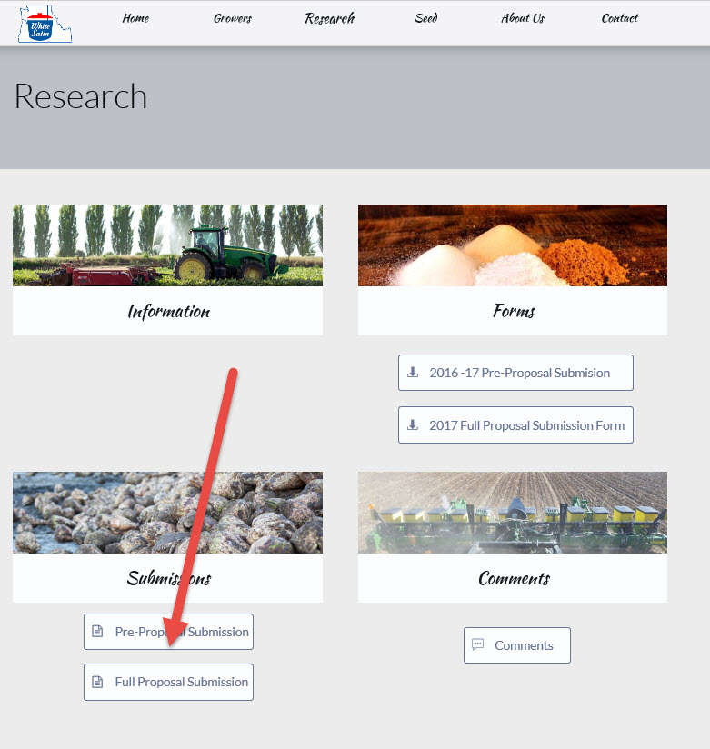

Click and will present upload screen:
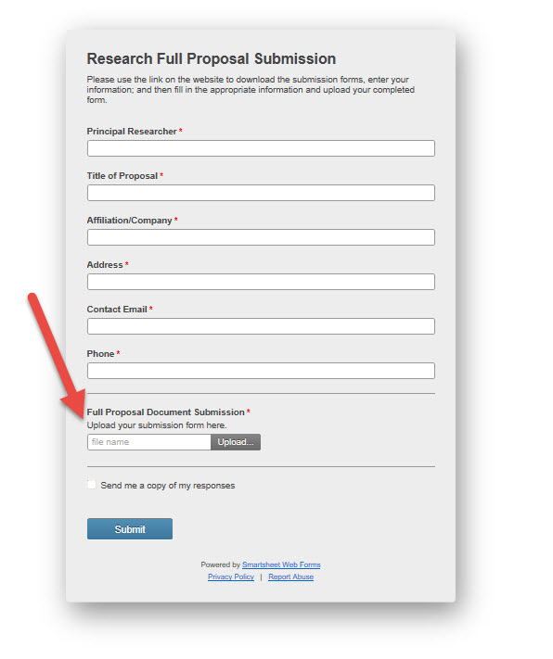
Don’t forget to attach your document file!

